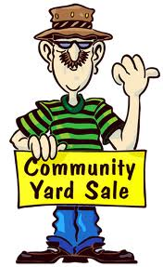
Date: Saturday April 27th
Where: READS Collaborative 101 East Grove St. Middleboro
Time: 9:00-2:00
~All proceeds from this yard/bake sale will help defray the cost of a Family Fun Day at Camp Yomechas on July 13th .This event will provide a day of fun and games for our Deaf, hard of hearing, deaf/blind and non-verbal friends and families.
How you can help……
- Donate items for the yard sale (clothes, furniture, house décor etc…)
- Donate baked goods for the bake sale.
- Volunteer to set up/clean up
- Volunteer to do face painting
- Share/post this event info
- Donate crafts/handmade items
~ Tables will be available for rent $15.00 each table

~ For more event info : donations, volunteers, table rentals, and questions, please contact Marianne Molinari :
manny66@msn.com

